**Assignment 2.8**

**HIVE**

Creating temporary table



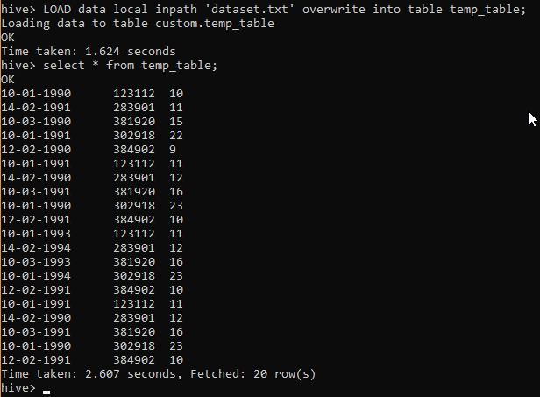

Creating the actual table



Inserting data after converting to correct date format



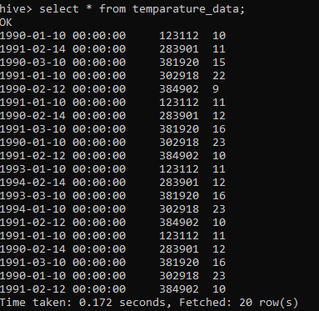

**Problem Statement**

1. **Fetch date and temperature from temperature_data where zip code is greater than 300000 and less than 399999.**

SELECT date_format(the_date,"MM-dd-YYYY"), temperature from temparature_data WHERE zipcode > 300000 AND zipcode < 399999;

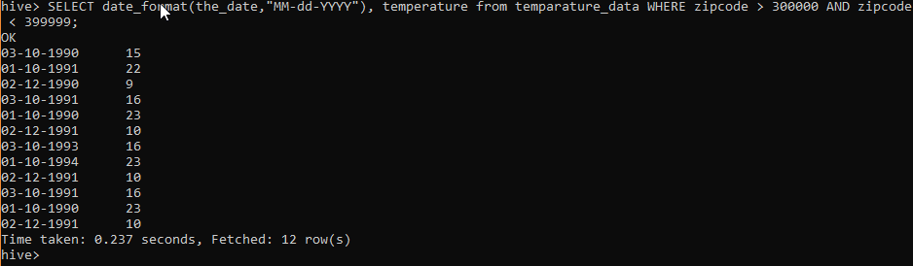

1. **Calculate maximum temperature corresponding to every year from temperature_data table.**

SELECT year(the_date) as the_year, MAX(temperature) from temparature_data GROUP BY year(the_date);



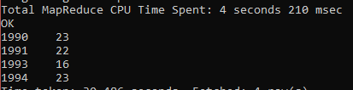

1. **Calculate maximum temperature from temperature_data table corresponding to those years which have at least 2 entries in the table.**

SELECT year(the_date) as the_year,MAX(temperature) as max_temp FROM temparature_data GROUP BY year(the_date) HAVING COUNT(year(the_date)) >= 2;



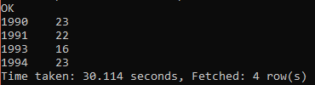

1. **Create a view on the top of last query, name it temperature_data_vw.**

CREATE VIEW temperature_data_vw AS SELECT year(the_date) as the_year,MAX(temperature) as max_temp FROM temparature_data GROUP BY year(the_date) HAVING COUNT(year(the_date)) >= 2;





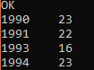

1. **Export contents from temperature_data_vw to a file in local file system, such that each file is '|' delimited.**

INSERT OVERWRITE LOCAL DIRECTORY '/home/acadgild/temperature_data_vw.txt' ROW FORMAT DELIMITED FIELDS TERMINATED BY '|' SELECT * FROM temperature_data_vw;



